The Guide for Writing the Two-Page Abstract in Microsoft Word for ISOT2021
Andrei Voronkov^{1,2}and Kryštof Hoder¹
¹EasyChair
²University of Manchester, Manchester, U.K.
andrei@voronkov.com, hoderk@cs.man.ac.uk

Abstract (Not more than 100 words)
Leave 1" margin on all sides of this document.. Use Times New Roman Font and Font size 10 throughout except the Section Headings which should be in font in font size 11, New Times Roman Font in Bold . The Title of the submission should be in font 14, Times New Roman and in Bold. The heading 'Abstract' should be in New Times Roman, font size 10, Bold. The Spacing between lines in the text is 1. The Title of a new section should be preceded from the preceding text by a blank line. Figure and Table captions should be in Font size 9.

1. Introduction
EasyChair is a conference management system that is flexible, easy to use, and has many features to make it suitable for various conference models. It is currently probably the most commonly used conference management system (Voronkov, EasyChair conference system, 2004), serving thousands of conferences every year.

2. Body
To produce a document complying with the EasyChair style you can simply take this guide and modify it. Several Word document styles are defined and used in this guide. To apply these styles in Microsoft Word you can use the Formatting Palette. The first line should contain the title of the document. This line should be followed by a line in the style Authors, which specifies authors of the publication, separated by commas, except for the last author
which is separated from the rest of the authors by an “and”. Next to each author there may be a super-script number linking the author to an organization (see above). and a footnote specifying the role of the author in preparation of the publication.
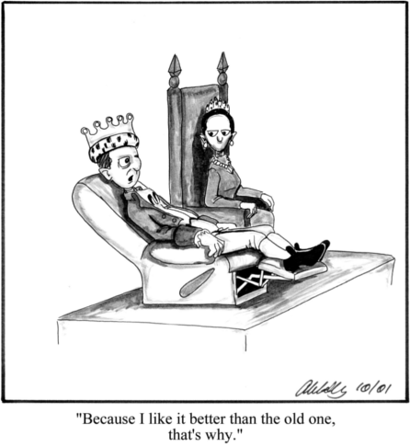

3. Adding Figures and Tables
In Microsoft Word, pictures can be inserted into the document by going to Insert->Picture->From File… on the menu and selecting the desired file. To simplify working with the image, it is recommended that you insert the picture into a text box. Figures should be referenced in the text as Fig. Figure Captions should be in New Times Roman, Font 9.

If you have a table in your document, captions can be created in the same way, just select “Table” from the “Label” drop-down list instead.
Table 1 shows an example of a table of data that was conveniently available.
ATP System | LTB /100 | Avg time | Prfs out | SOTA Con. | μ  Eff. | CYC /35 | MZR /40 | SMO /25
Vampire-LTB 11.0 | 69 | 24.5 | 69 | 0.37 | 28.1 | 23 | 22 | 24
iProver-SInE 0.7 | 67 | 76.5 | 0 | 0.36 | 8.8 | 28 | 14 | 25
SInE 0.4 | 64 | 75.3 | 64 | 0.32 | 8.5 | 26 | 13 | 25
leanCoP-SInE 2.1 | 35 | 110.8 | 35 | 0.23 | 3.2 | 23 | 1 | 11
E-LTB 1.1pre | 18 | 63.4 | 0 | 0.21 | 2.8 | 7 | 9 | 2
EP-LTB 1.1pre | 18 | 77.8 | 18 | 0.21 | 2.3 | 7 | 9 | 2
E-KRH'-LTB 1.1.3 | 0 | - | - | - | - | 0 | 0 | 0

Table 1: LTB division results

4. Equations
Use equations editors to create equations. Do not paste equations as pictures. Equations should be left justified.
The font size $should be 10.$ Equation numbers should be placed on the right extreme of the line.

$f\left(x\right)=a_{0}+\sum_{n=1}^{∞}{\left(a_{n}\cos{\frac{nπx}{L}}+b_{n}\sin{\frac{nπx}{L}}\right)}$ (1)

5. Conclusion and Discussions
The above is a brief guideline for a two page abstract for all ISOT 2021 submissions. It is on the basis of this abstract that the reviewers will accept your submission. Therefore be sure to include the importance of the work, its novelty, and atleast one noteworthy result (even if preliminary ones). Try to pack in as much information within these two pages as you possibly can since the final and accepted version of this two page abstract is to be published in the ISOT2021 Digest.

Acknowledgement
We gratefully acknowledge EasyChair from whose manuscript preparation template some of the text, the figure and table are taken.

References
- Carlisle, D. (2010, April). graphicx: Enhanced support for graphics. Retrieved from http://www.ctan.org/tex-archive/ help/Catalogue/entries/graphicx.html
- Voronkov, A. (2004). EasyChair conference system. Retrieved from easychair.org
- Voronkov, A. (2014). Keynote talk: EasyChair. In Proceeedings of the 29th ACM/IEEE International Conference on Automated Software Engineering (pp. 3-4). ACM.

